Citizen AI Project Documentation

# 1. Introduction

• Project Title: Citizen AI with IBM

Team ID : NM2025TMID08128

Team Leader : ABINAYA P(AF980867C69F841BA4D4C216837D8278)

Team member : ABINAYA P

Team member :ANANTHAPRIYA T

Team member : ARCHANA B

Team member : ARTHIKA R

# 2. Project Overview

Citizen AI uses the Granite model from Hugging Face to give quick, helpful answers about government services and civic issues. It tracks public sentiment and shows simple dashboards for officials to see feedback. This project is deployed in Google Colab using Granite for easy, low-cost setup and reliable performance.

# 3. Pre-requisites

• Gradio Framework Knowledge

• IBM Granite Models (Hugging Face)

• Python Programming Proficiency

• Version Control with Git

• Google Colab’s T4 GPU Knowledge

# 4. Project Workflow

• Activity-1: Exploring Naan Mudhalavan Smart Interz Portal.

• Activity-2: Choosing an IBM Granite Model from Hugging Face.

• Activity-3: Running Application in Google Colab.

• Activity-4: Uploading your Project in GitHub.

# 5. Architecture

Frontend (Gradio): Provides a simple interface for citizens to ask queries and view dashboards.

Backend (Google Colab + Python): Runs the AI model, processes civic queries, and generates responses.

Model (IBM Granite - Hugging Face): Powers natural language understanding and response generation.

# 6. Setup Instructions

• Search for 'Google Colab' and open a new notebook.

• Change runtime type to T4 GPU.

• Run the command: !pip install transformers torch gradio -q

• Run the Citizen AI code provided in the guided project.

• Click the URL generated to launch the Gradio Application.

# 7. Folder Structure

The project uses Colab and GitHub, with structure as:

• citizen_ai.ipynb – Main Google Colab notebook

• requirements.txt – List of dependencies

• app.py – Gradio app script

• README.md – Documentation for GitHub repository

# 8. Running the Application

➢ Launch the Colab Notebook.  
➢ Install dependencies.  
➢ Run the notebook cells to start the model.  
➢ Open the Gradio app link.  
➢ Citizens can type queries and officials can view dashboards.

# 9. API Documentation

The project does not expose separate APIs but supports interactions via Gradio.

Key functionalities include:

• Answering questions about government services

• Tracking public sentiment

• Displaying dashboards for civic feedback

# 10. Authentication

The demo version runs openly in Colab.

Secure deployment may include:

• API Key authentication

• Role-based access (citizen, official, admin)

• OAuth2 integration for secure logins

# 11. User Interface

The UI is created using Gradio, featuring:

• Input field for citizen queries

• Dashboard displaying feedback and trends

• Real-time response display

# 12. Testing

Testing includes:

• Unit testing core Python functions

• Manual testing of query responses

• Checking accuracy of dashboards

• Edge case handling for invalid queries

**13. Screenshots**

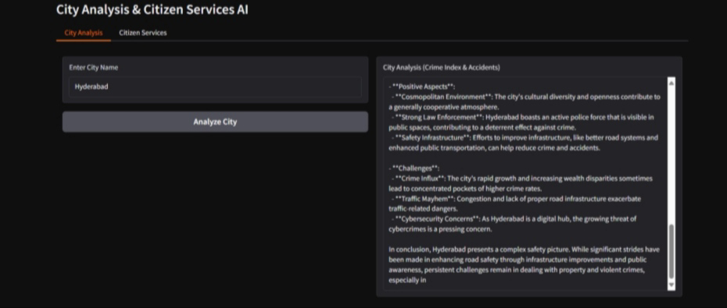

# .14. Known Issues

• Dependency installation errors in Colab

• Delays in model response due to limited GPU availability

• Basic dashboards may lack advanced visualization features

# 15. Future Enhancements

• Adding multilingual support for diverse citizens

• Expanding dashboard with richer analytics

• Deploying as a web-based portal outside Colab

• Integration with government APIs for real-time data